EXPT 5.1: Implementation of an IoT-Based Smart Home Automation Network Using Cisco Packet Tracer

Objectives
(i) To design and configure an IoT smart home network with PC-based monitoring and control, integrating IoT devices, an access point, a switch, and an IoT server to enable centralized management of smart appliances.
Software/Apparatus required:
(i) Cisco Packet Tracer
(ii) End Devices (PCs)
(iii) Switches
(iv) Copper Straight-through Cable / Automatic Cable Selector
(v) Routers
(vi) Server (DHCP)
(vii) Household devices (Fan, AC, Light, Garage door)
Procedure:
Objective 1: PC based monitoring
1. Open Cisco Packet Tracer and create a new workspace.
2. Add a Home Gateway/Access Point, Switch, Server, PC, and IoT devices (Fan, Air Conditioner, Garage Door, and Light).
3. Connect the Server and Home Gateway to the Switch using copper straight-through cables.
4. Configure IP addressing for the Server and PC.

5. Enable IoT services on the Server and create a user account.
6. Connect the IoT devices wirelessly to the Home Gateway.
7. Register all IoT devices with the IoT Server.
8. Verify that the devices appear in the IoT Server dashboard.
9. Access the IoT Server from the PC using a web browser.
10. Monitor and control the IoT devices through the PC interface and verify their operation.
Network Diagram:
Objective 1: PC based monitoring
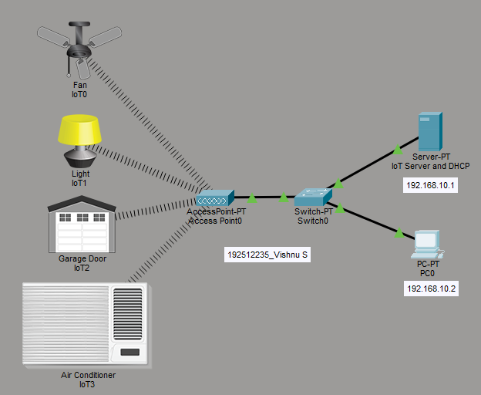

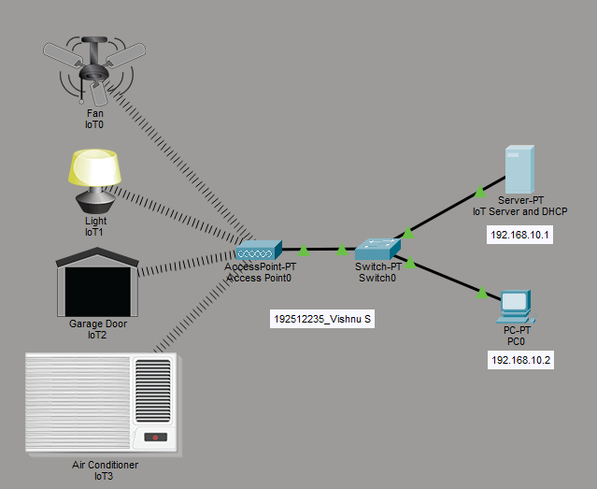

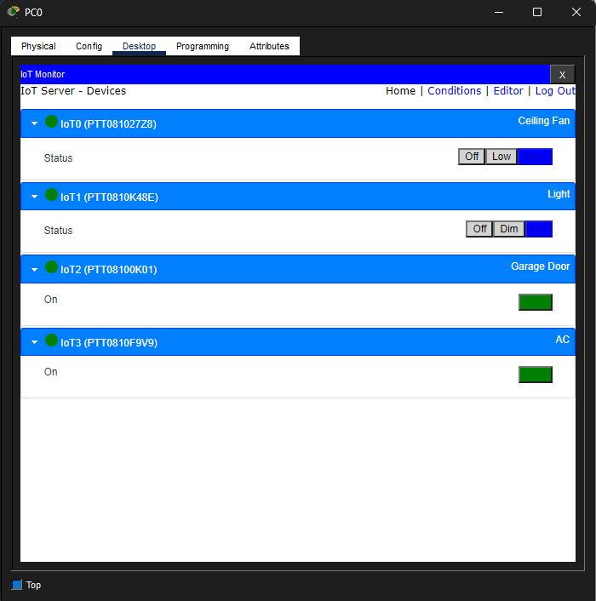

Objective 1: PC based monitoring
Things | Default | Control
Fan | Off | High
AC | Off | On
Garage Door | Close | Open
Light | Off | On

Result
Objective 1: PC based monitoring
The IoT smart home network was successfully configured, and the PC was able to monitor and control the connected IoT devices through the server.

